1. **LESSON TITLE:**
   * Type here
2. **LESSON OBJECTIVES:**

* Type here

1. **PRIOR KNOWLEDGE:**

* Type here

1. **STAGES AND TIME ALLOCATION:**

|  |  |  |
| --- | --- | --- |
| **Stage** | **Activity** | **Duration** |
| **0** |  | **? mins** |
| **1** |  | **? mins** |
| **2** |  | **? mins** |
| 2.1 |  | ? mins |
| 2.2 |  | ? mins |
| 2.3 |  | ? mins |
| **3** |  | **? mins** |
|  | **TOTAL TIME** | **? MINUTES** |
| **Attire** |  | |
| **Targeted Participants** |  | |
| **Location** |  | |

1. **TRAINING PERSONNEL:**

|  |  |  |
| --- | --- | --- |
| **Roles** | **Name of personnel** | **Remarks** |
|  |  |  |
|  |  |  |

1. **EQUIPMENT AND LOGISTICS:**

|  |  |  |
| --- | --- | --- |
| **Logistic** | **Remarks** | **Quantity** |
|  |  |  |
|  |  |  |
|  |  |  |

1. **METHOD OF INSTRUCTION:**

|  |  |  |
| --- | --- | --- |
| **Stage** | **Activity** | **Remarks** |
|  |  |  |
|  |  |  |
|  |  |  |
|  |  |  |
|  |  |  |
|  |  |  |
|  |  |  |

1. **ADMINISTRATION**

* Budget:
* Transport / Ration:
* Medical:

1. **SAFETY PRECAUTIONS**

* Type here

1. **CONTINGENCY PLANS**

* Type here

1. **REFERENCES**

* Type here

1. **AUTHENTICATION**

* Prepared by: ,
* Vetted By:
* Date:

**1. Why must I plan for a lesson?**

Because lesson planning:

* Lends structure to an activity
* Provides coherence, direction and clarity
* Allows the lesson to be carried out by any other person
* Is a means to track learning

**2. What are the parts of a lesson?**

There are 14 parts for a lesson plan (in NPCC context). They are:

(1) Lesson title:

* The title of your lesson

(2) Lesson Objectives:

* This section lists your objectives for the lesson.

(3) Prior Knowledge:

* This section lists the information that your audience must know before attending your lesson.

(4) Stages and Time Allocation

You need to include:

* The brief stages of your lesson
* The duration of each stage
* The schedule for training which can be organized in the format of a table as shown below:

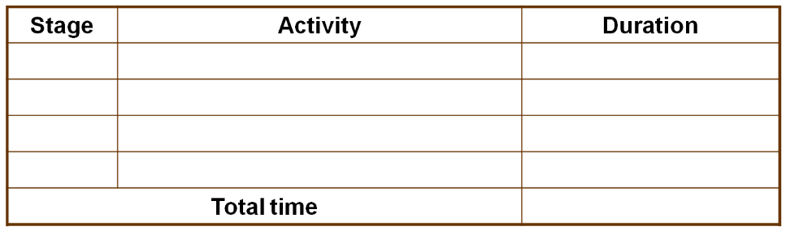

Note: Ensure that sufficient time is given for each stage, be mindful of your total time available, and ensure that the lesson is systematic and flows well.

(5) Location:

* Where you want your lesson to be conducted
* Maximum use of space available

(6) Group of trainees:

* Identify your target audience

(7) Methodology

* While doing this part, we must bear in mind:
* What is the purpose of this stage for the person conducting the lesson
* Who will be reading this lesson plan (the person who will actually be taking the lesson)
* Things that the instructor has to note: instructors must be so detailed that the lesson can go as planned
* Check to see if instructions are sufficient

(8) Organisation of lesson

* Training Personnel:
* Number of conductors needed for the lesson
* Equipment needed and visual aids needed for the lesson

(9) References

* Places or documents that you took your information from (websites, books etc)

(10) Attire

* Attire (what to wear) for BOTH instructors and trainees

(11) Safety Precautions

* “Mini” risk assessment: what should be done to minimize the possibility of instructors and trainees getting hurt

(12) Administration

* Transport: if any is needed (quantity, one-way or two-way)
* Ration: food that needs to be provided (if any)
* Medical: medications or medical help that would be needed in your lesson in case of any emergencies

(13) Other Preparations:

* Wet Weather Programme: The entire wet weather plan
* Rain before activity
* Rain during activity

(14) Authentication

* Who the lesson is prepared by, and the date the lesson was prepared

**3. How do I evaluate my lesson plan?**

You may decide to follow the 5 guiding questions below to evaluate your lesson plan:

(1) Is my lesson plan accurate?

* A good lesson plan is
* Well researched with information from a variety of sources
* Accurate: it is updated and proof-read

(2) Is there sufficient detail?

* A good lesson plan is
* Detailed and well documented
* Has a clear breakdown of information

(3) Are my objectives clear and feasible?

* Clear goals and objectives inform learners what they are expected to achieve
* Content and activities should be crafted to meet these objectives
* Limit the number of objectives per lesson

(4) What factors affect the methods used?

* When planning your methodology, consider
* Learners’ needs: Tailor the method used to match the majority learning style of your audience
* Group Size: Generally, the larger the group, the less attentive.

(5) Is the flow of the lesson smooth?

* Consider the sequence of activities or games throughout the lesson
* Sequence of activities should be logical and the transition should not be awkward

(6) Will I benefit my audience to the maximum?

There are 6 factors to consider:

* Resources available
* What are the visual aids that I can use, and how can I maximize their use
* Manpower available
* Desired instructor: student ratio (dependant on group size)
* Competency of instructors
* Alternative plans
* Are my wet weather plans able to meet the original objectives?
* Time allocated
* Ensure that the amount of content to be covered is comfortable for the time limit of the lesson given
* Decide the amount of time to be spent on each section
* Plan for buffer time (in case of delays etc)
* Content
* This depends on the aptitude of your learners.
* Present information in simple terms
* Avoid going too much into detail or too deep into a topic
* Learning Styles
* 3 Main learning styles:
* Visual
* Auditory
* Kinesthetic

**Three main types of learning styles**

|  |  |  |  |
| --- | --- | --- | --- |
|  | Visual | Auditory | Kinesthetic |
| Characteristics | - Learn through seeing  - Enjoys pictures diagrams and colour  - May think in pictures and learn best from visual displays | - Learn through listening  - Likes discussion talking things through and hearing what others have to say  - Interprets the underlying meaning of speech through listening to tone and pitch of voice | - Learn through moving, doing, and touching.  - Remembers better what was done rather than what was said or seen  - Relies on what they can directly experience |
| Tips for teaching | - Use colour to highlight important points  - Use visual aids such as diagrams and pictures  - Provide handouts and encourage them to take notes | - Include class discussion and presentation to encourage active participation | - Vary activities and provide frequent breaks  - Include more hands-on activities  - Draw mind maps to illustrate information |

**4. As a Cadet Leader, when will I have to do lesson planning?**

You will have opportunities to do lesson planning when you teach your juniors:

* Drills
* Campcraft
* Games
* Others

**5. After planning the lesson, how do I deliver the lesson?**

* Adopt a systematic approach
  + Introduction
  + Formation of squad/groups
  + Instructional section
  + Activities/Games
  + Conclusion
* Follow your lesson plan
* End with a Q&A session for clarifications